

**Course Information**

Course Title: Digital Image Processing

Section: 1

Course Instructor: Dr. Ahmed Wasif Reza

Associate Professor

Department of Computer Science & Engineering

**Lab-06**

**Student’s Information**

**Name:** Mujahidul Islam

**ID:** 2019-2-60-072

**Department:** Computer Science & Engineering

**Date of Submission: 1 December 2022**

**Question 1**

**Apply three types of highpass filtering in the frequency domain on Figure 1;**

**A. Ideal highpass filter (IHPF)**

**B. Butterworth highpass filter (BHPF)**

**C. Gaussian highpass filter (GHPF)**

A)

input_image = imread('Brain MRI.png');

[M, N] = size(input_image);

FT_img = fft2(double(input_image));

D0 = 30;

u = 0:(M-1);

idx = find(u>M/2);

u(idx) = u(idx)-M;

v = 0:(N-1);

idy = find(v>N/2);

v(idy) = v(idy)-N;

[V, U] = meshgrid(v, u);

D = sqrt(U.^2+V.^2);

H = double(D <= D0);

G = H.*FT_img;

output_image = real(ifft2(double(G)));

subplot(2, 2, 1), imshow(input_image), title('Original Image');

subplot(2, 2, 2), imshow(output_image, [ ]), title('After LPF');

**Output:**

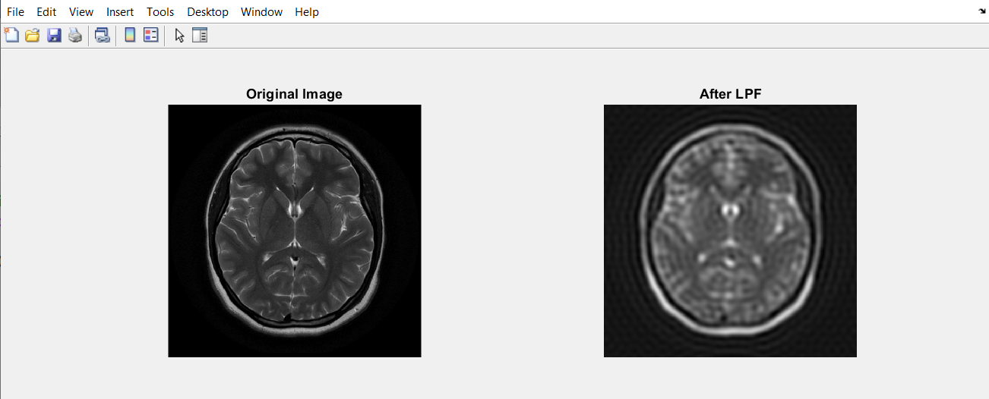

**B)**

input_image = imread('Brain MRI.png');

[M, N] = size(input_image);

FT_img = fft2(double(input_image));

n = 2;

D0 = 20;

u = 0:(M-1);

v = 0:(N-1);

idx = find(u > M/2);

u(idx) = u(idx) - M;

idy = find(v > N/2);

v(idy) = v(idy) - N;

[V, U] = meshgrid(v, u);

D = sqrt(U.^2 + V.^2);

H = 1./(1 + (D./D0).^(2*n));

G = H.*FT_img;

output_image = real(ifft2(double(G)));

subplot(2, 2, 1), imshow(input_image), title('Original Image');

subplot(2, 2, 2), imshow(output_image, [ ]), title('After BLF');

**Output:**

**C)**

img = imread('Brain MRI.png');

[m, n] = size(img);

fc = 10;

p = round(m/2);

q = round(n/2);

H = zeros(m,n);

for i = 1:m

for j = 1:p

d = (i-p).^2 + (j-q).^2;

H(i, j) = exp(-d/2/fc/fc);

end

end

A_f = fftshift(fft2(img));

B = A_f.*H;

C = abs(ifft2(B));

glpf = uint8(C);

subplot(2, 2, 1), imshow(img), title('Original Image');

subplot(2, 2, 2), imshow(glpf), title('After GLPF');

**Output:**

**Question 2**

**Apply three types of lowpass filtering in the frequency domain on Figure 1;**

**A. Ideal lowpass filter (ILPF)**

**B. Butterworth lowpass filter (BLPF)**

**C. Gaussian lowpass filter (GLPF)**

**A)**

input_image = imread('Brain MRI.png');

[M, N] = size(input_image);

FT_img = fft2(double(input_image));

D0 = 10;

u = 0:(M-1);

idx = find(u>M/2);

u(idx) = u(idx)-M;

v = 0:(N-1);

idy = find(v>N/2);

v(idy) = v(idy)-N;

[V, U] = meshgrid(v, u);

D = sqrt(U.^2+V.^2);

H = double(D > D0);

G = H.*FT_img;

output_image = real(ifft2(double(G)));

subplot(2, 2, 1), imshow(input_image), title('Original Image');

subplot(2, 2, 2), imshow(output_image, [ ]), title('After LHF');

**Output:**

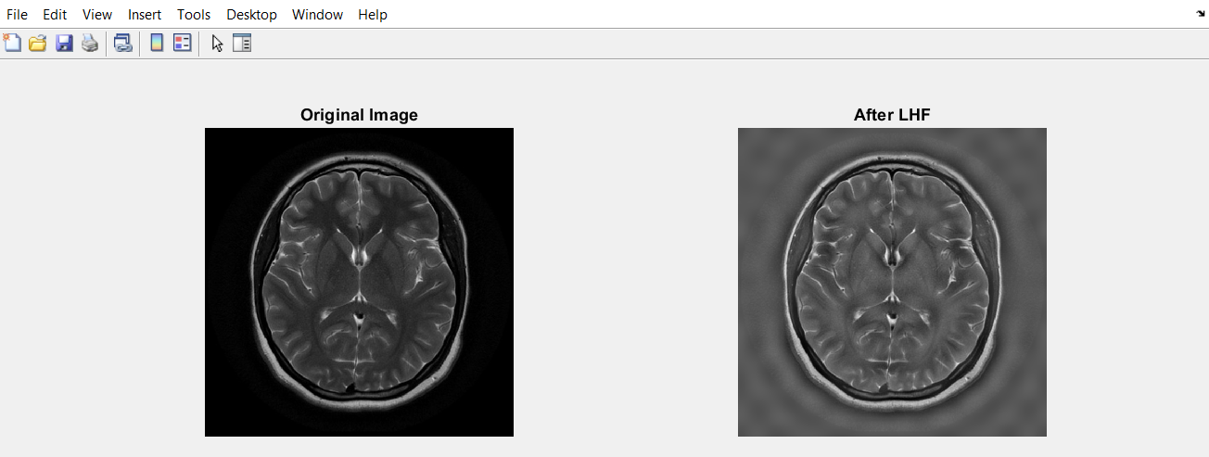

**B)**

input_image = imread('Brain MRI.png');

[M, N] = size(input_image);

FT_img = fft2(double(input_image));

n = 2;

D0 = 10;

u = 0:(M-1);

v = 0:(N-1);

idx = find(u > M/2);

u(idx) = u(idx) - M;

idy = find(v > N/2);

v(idy) = v(idy) - N;

[V, U] = meshgrid(v, u);

D = sqrt(U.^2 + V.^2);

H = 1./(1 + (D0./D).^(2*n));

G = H.*FT_img;

output_image = real(ifft2(double(G)));

subplot(2, 2, 1), imshow(input_image), title('Original Image');

subplot(2, 2, 2), imshow(output_image, [ ]), title('After BHF');

**Output:**

**C)**

img = imread('Brain MRI.png');

[m, n] = size(img);

fc = 10;

p = round(m/2);

q = round(n/2);

H = zeros(m,n);

for i = 1:m

for j = 1:p

d = (i-p).^2 + (j-q).^2;

H(i, j) = exp(-d/2/fc/fc);

end

end

H = 1-H;

A_f = fftshift(fft2(img));

B = A_f.*H;

C = abs(ifft2(B));

ghpf = uint8(C);

subplot(2, 2, 1), imshow(img), title('Original Image');

subplot(2, 2, 2), imshow(ghpf), title('After GHPF');

**Output:**

**Question 3**

**Accurate diagnosis is the most vital part of the healthcare sector. For a precise diagnosis, the test results must display the features as clearly as possible. According to your observations while solving the previous problems, which filtering technique would you choose if you were given the task of performing image enhancement on the given image? Explain and justify your reasoning.**

**Answer:**

**Low pass filter:** The kind of frequency domain filter used to smooth the image is called a low pass filter. The low frequency components are preserved while the high frequency components are attenuated.

**High pass filter:** The type of frequency domain filter used to sharpen the image is called a high pass filter.

Here for medical image processing I will use **Gaussian Low pass filtering** and **Gaussian High pass filtering.** Because it seems smoother and sharper image.

**Question 4**

**Apply Hough transform to Figure 2 and draw the detected lines on the original image.**

img = imread('X-Ray Image.png');

I = im2bw(img);

rotI = imrotate(I,33,'crop');

fig1 = imshow(rotI);

BW = edge(rotI,'canny');

figure, imshow(BW);

[H,theta,rho] = hough(BW);

figure, imshow(imadjust(mat2gray(H)),[],'XData',theta,'YData',rho,...

'InitialMagnification','fit');

xlabel('\theta (degrees)'), ylabel('\rho');

axis on, axis normal, hold on;

colormap(hot)

P = houghpeaks(H,5,'threshold',ceil(0.3*max(H(:))));

x = theta(P(:,2));

y = rho(P(:,1));

plot(x,y,'s','color','black');

lines = houghlines(BW,theta,rho,P,'FillGap',5,'MinLength',7);

subplot(2, 2, 1), imshow(img), title('Original Image');

subplot(2, 2, 2), imshow(rotI),title('Output Image'), hold on

max_len = 0;

for k = 1:length(lines)

xy = [lines(k).point1; lines(k).point2];

plot(xy(:,1),xy(:,2),'LineWidth',2,'Color','green');

end

**Output:** 